PRATHIKSHA S

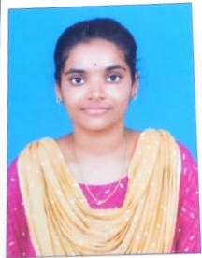D/o.Senthilkumar,

2/91, Mela street,

Mangalam-621 205.

Musiri(TK),

Trichy(DT).

E-MailID:[prathiksha1908@gmail.com](mailto:prathiksha1908@gmail.com) Mobile No:8608012157

**CAREEROBJECTIVE**

To secure a challenging position in a reputable organization to expand my learnings, knowledge, and skills.

**ACADEMICPROFILE:**

|  |  |  |  |  |
| --- | --- | --- | --- | --- |
| **NAMEOFTHE COURSE** | **NAME OF INSTITUTION** | **UNIVERSITY/ BOARD** | **YEAROF PASSING** | **PERCENTAGE OF MARKS** |
| **(BCA-Bachelor of computer application)** | MIT college of Arts and Science for women, Musiri | Bharathidasan University | 2024  (Pursuing) | 89% |
| **HSC** | GHSS,  Paithamparai | StateBoard | 2021 | 78% |
| **SSLC** | Amala Girls Hr.Sec.School, Musiri | StateBoard | 2019 | 68% |

# SKILLS

* Typewriting English with First class
* C , Python

# PERSONALPROFILE

Name : **PRATHIKSHA S**

Father’sName : Sethilkumar S

DateofBirth : 19.08.2004

Gender : Female

MaritalStatus : Unmarried

Nationality : Indian

Religion : Hindu Language known : English,Tamil

# HOBBIES

* Travelling ,Cooking, Music

# DECLARATION

I hereby declare that the details and information given above are complete and true to the best of my knowledge.

Place:

Date: (PRATHIKSHA S)